Risk assessment matrix

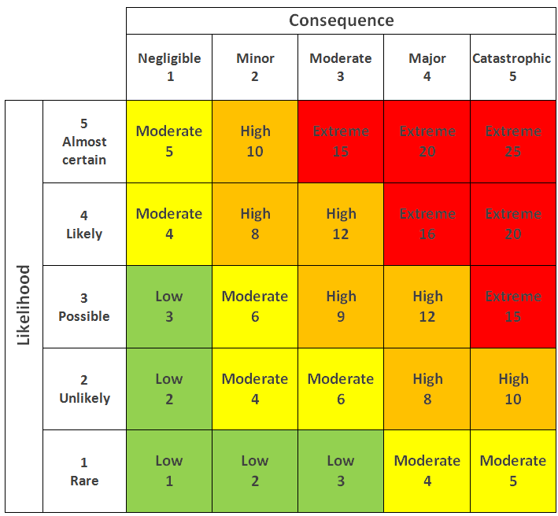

Risk log (register)

| **ID** | **Risk Description** | **Probability** | **Impact** | **Risk Category** | **Impact** | **Control** |
| --- | --- | --- | --- | --- | --- | --- |
| **1** | Natural Disasters | 1 | 5 | 5 | Large damage to physical property and large amounts of downtime. | Back up data and essential files to the cloud. |
| **2** | Unclear Scope | 5 | 3 | 15 | Plans and Project details will constantly be changing. | Ask the client as many questions as possible to get as much an idea as we can. Further changes can be dealt with in weekly meetings |
| **3** | Going Over Budget | 2 | 5 | 10 | Project will spend over our guaranteed budget leading to stakeholders being displeased and possibly abandoning the project. | Keep the Cost Benefit Diagram constantly updated so we can keep track of our finances. If the budget is over, then renegotiations with the client. |
| **4** | Project Not Being Delivered On-Time | 2 | 5 | 10 | Project will go over our Time Frame leading to stakeholders being displeased and possibly abandoning the project. | To prevent this, we need to stay on top of our scope to prevent last-minute changes to the project and stay on top of the Gantt chart so that we are on track. |
| **ID** | **Risk Description** | **Probability** | **Impact** | **Risk Category** | **Impact** | **Control** |
| **5** | Customers Lack Of Technical Skills | 3 | 3 | 9 | The customers are unable to use the software they have created, leading to changes to the system | Prevention can happen by testing thoroughly so that it fits for purpose. |
| **6** | Server Going Down/Being Overloaded | 1 | 3 | 3 | The system may go down due to a technical fault or too many people using the system at once | -Fix the system when it goes down  -Test Thoroughly |
| **7** | DDoS attack | 2 | 5 | 10 | System will go down, and data will be lost | Keep systems secure by insuring high levels of network security |
| **8** | Inaccurate bus timetables | 3 | 2 | 6 | The data we provide to the customer will be wrong | Keep API calls frequent |